**Software Engineering SE(CE-202L)**

**Spring Semester 2023**

# **Semester Project Report**

# SSUET_Logo

**FIFA PLAYER MANAGEMENT SYSTEM**

**Submitted By:**

Arisha Fateh (2020F-BCE-117)

Arbaz Moin (2020F-BCE-111)

Talha Hussain Khan (2020F-BCE-114)

Ahmed Baseer (2020F-BCE-124)

**Submitted To:**

Mam Safina Soomro

Mam Maheen Danish

**Computer Engineering Department**

Sir Syed University of Engineering & Technology

University Road, Karachi 75300

<http://www.ssuet.edu.pk>

**ABSTRACT**

Managing the ever-increasing numbers of players in different parts of the world is a huge task. This project is aimed at developing a ‘Fifa Player Management System’ for managing players using a database at the backend and a Web based GUI at the frontend.

This will allow users to track complete details about a player starting from his personal details, going through club and nationality information to right down to his technicalities at each position in footballing world. Users have the privilege to add new players to a particular team, and to modify their records when the player decides to retire. Fifa Player Management System also allows users to access players based on their rating other than their preferential position of playing thus guiding managers to build a strong positional team by selecting best rated player at each position. In conclusion, this application will come extremely handy in maintaining player spread across different teams and nations.

# **ACKNOWLEDGEMENT**

We have taken efforts in this project. However, it would not have been possible without the kind support and help of many individuals and organizations.

We would like to extend our sincere thanks to all of them. We are highly indebted to teachers for their guidance and constant supervision as well as for providing necessary information regarding the project & also for their support in completing the project.

We would like to express our gratitude towards members of project for their kind co-operation and encouragement which help us in completion of this project. We would like to express our special gratitude and thanks to industry persons for giving us such attention and time.

Our thanks and appreciations also go to our Project partners in developing the project part from the efforts of myself, the success of any project depends largely on the encouragement and guidelines of many others. We take this opportunity to express our gratitude to the people who have been instrumental in the successful completion of this project. We would like to show our greatest appreciation to **Mam Safina Soomro**.

We can’t say thank you enough for your tremendous support and help. We feel motivated and encouraged every time we attend your meeting. Without your encouragement and guidance this project would not have materialized. The guidance and support received from all the members who contributed and who are contributing to this project, was vital for the success of the project. We are grateful for their constant support and help.

# **INTRODUCTION**

The project titled “**Fifa player Management System**” is player management software for monitoring and accessing players. This project is developed using HTML, CSS and JavaScript for front-end and PHP, MySQL for back-end, which focuses on basic operation like adding a new player, searching players with detailed information and edit as they grow their skills.

This project is a web based application designed and developed to help user’s access players and organize teams. This software is easy to use, and it features a familiar and well- thought-out attractive user interface, combined with strong searching, insertion, and deletion with procedure capabilities.

Analyzing players have been a huge task performed by professional scouting agents who are spread around the world. From personal details to soccer technicalities, Soccer game system allows easy maintenance record of such skilled youth talent.

# **DESCRIPTION**

This project consists of player details, which describes about player biodata such as age and nationality. It also consists of player stats which describes about players technical skills. It also consists of tables containing details such as player earnings, club information and preferred position of playing. It also provide a strong searching, updating, deleting and inserting operations with a user friendly web based UI.

The project also helps the users to keep track of the player details in a computerized way without any trouble. The project contains **7 stored procedures** and 3 triggers per table. Stored procedures are used in search engine. Every time the user searches through the database, a procedure is called and the results is collected and displayed for the user in a structured manner. It also has 3 trigger namely “**Insert, Delete and Update**” triggers assigned separately to each table. Whenever operations such as insert or delete or update is performed on any table, these triggers are automatically called, and the logs are captured into 3 separate tables, individually for each trigger. Hence use of triggers provides users to trace back all the latest as well as the oldest changes into any table at any point of time.

This project is a simple prototype of managing larger numbers of players across different nations with different skill sets and attributes. It helps to access players and thus aids in building a strong positional team. It also helps in monitoring player growth.

**ER Diagram:**

**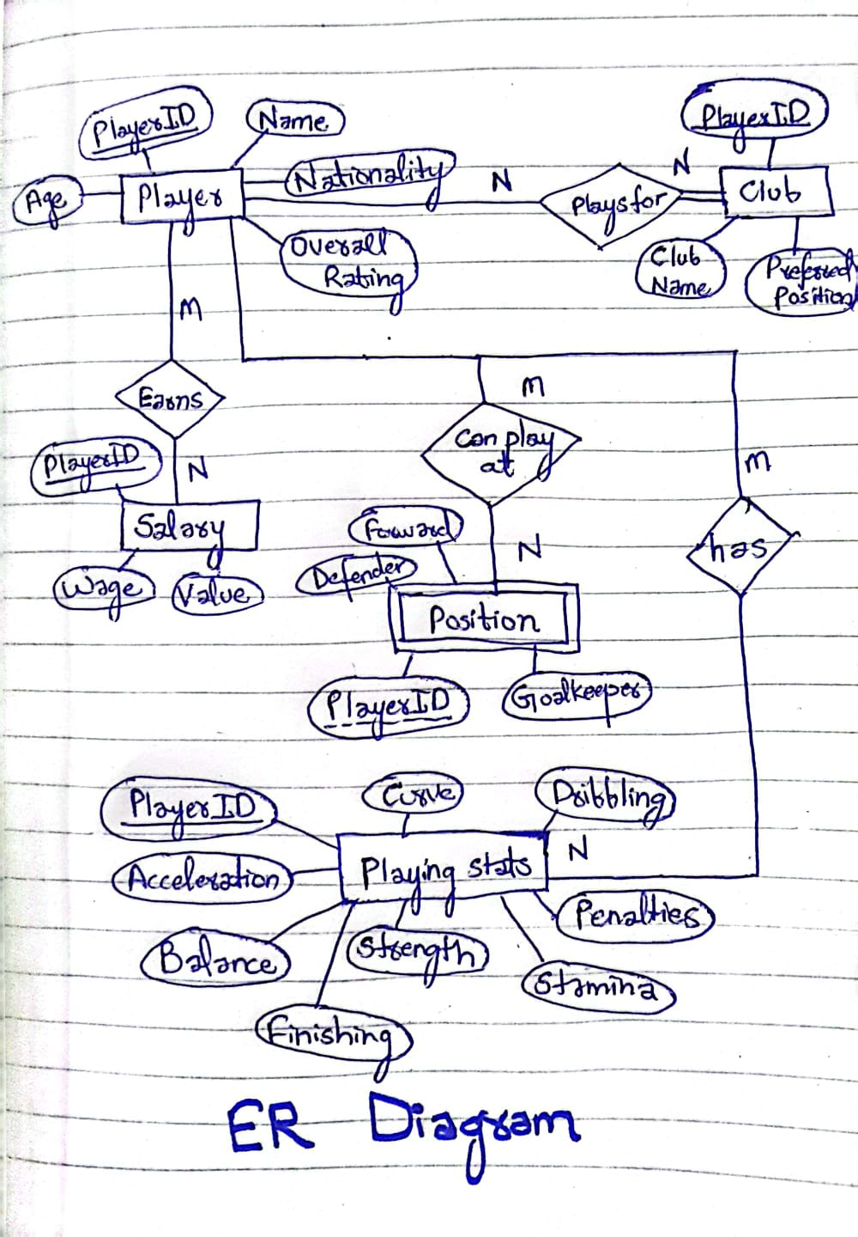**

# **TRIGGERS**

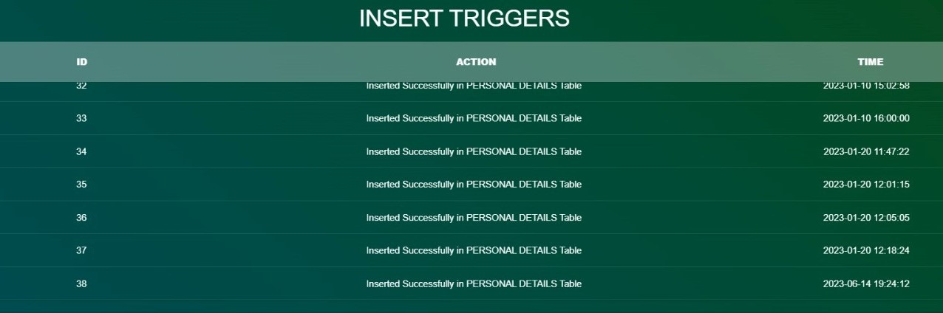

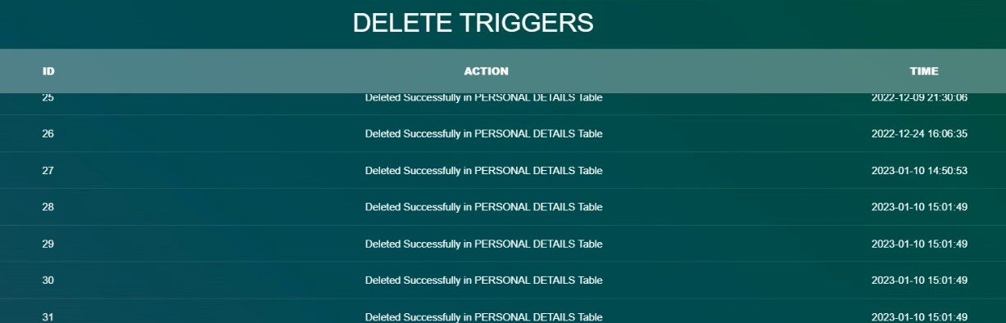

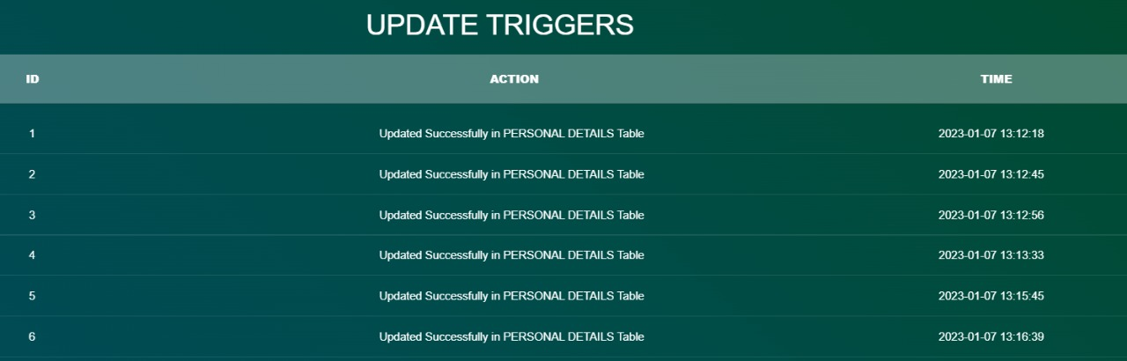

# **METHODOLOGY**

First we get research of the latest project and after doing many practices we get it to one project then we worked for coding of the project. We worked on HTML, CSS and JavaScript for front-end and PHP, MySQL for back-end, which focuses on basic operation like adding a new player, searching players with detailed information and edit as they grow their skills. We have implemented latest tools in our code. Then we check for bugs in our project then after taking actions on our error we have tested our code to find out results. We have designed our project according to need of today’s evolving era. We make a sustainable project that others can also work on it. We analyze problems and get solution for it. We have implemented and give the final outcome and test our code and remove bugs and errors. We had used latest tools to make our code comparable with the latest technologies.

# **OUTPUT**

* Home Page



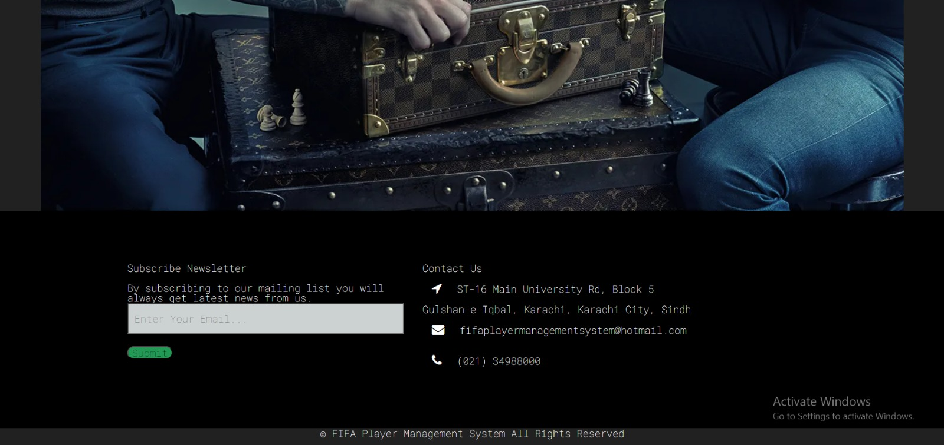

# **Database**

# 

* After inserting new database

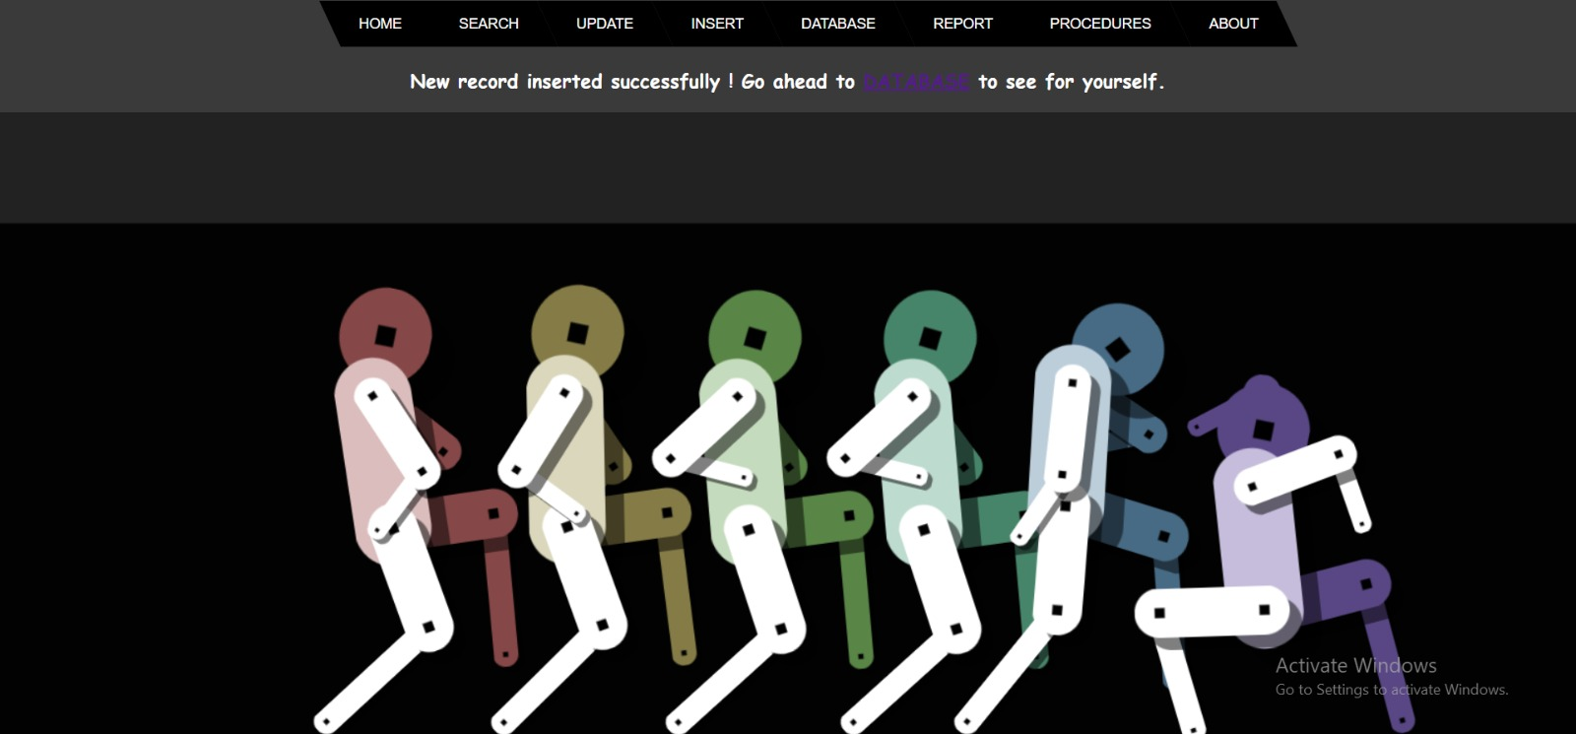

# **Update**

cc

* **Search**

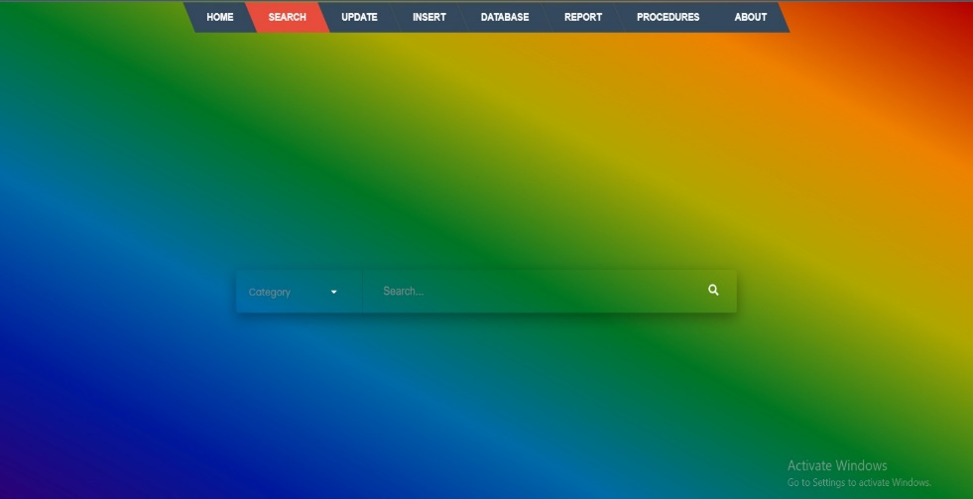

# **Insert**

# 

# **About**



**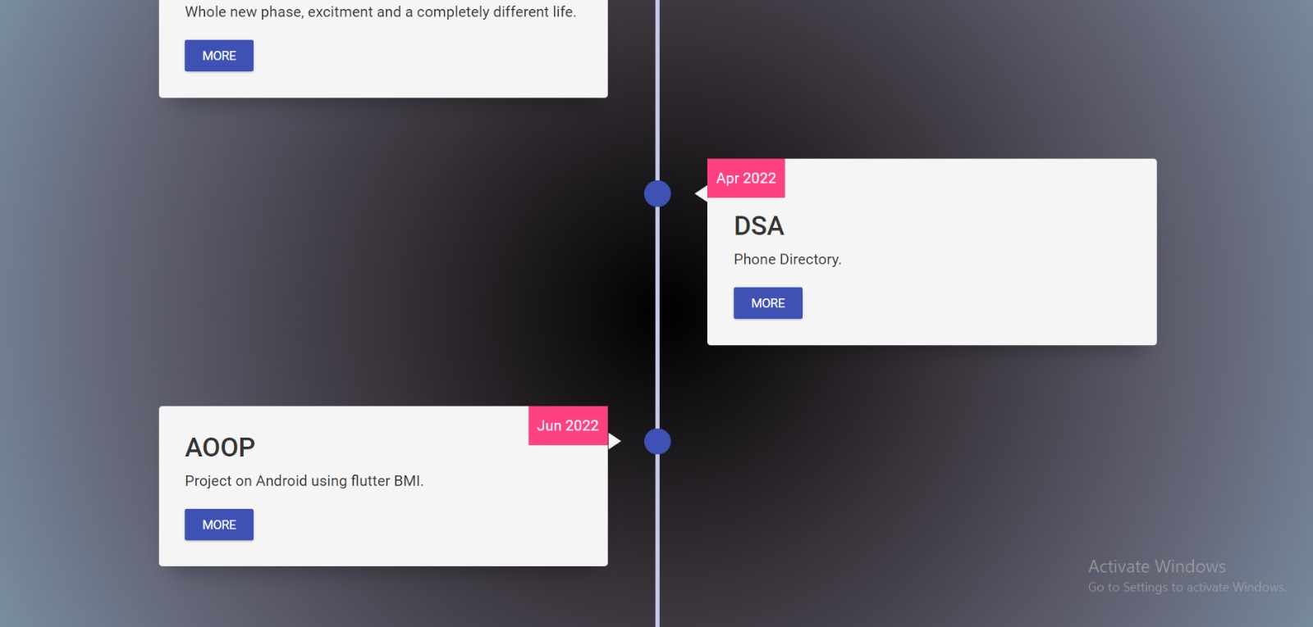**

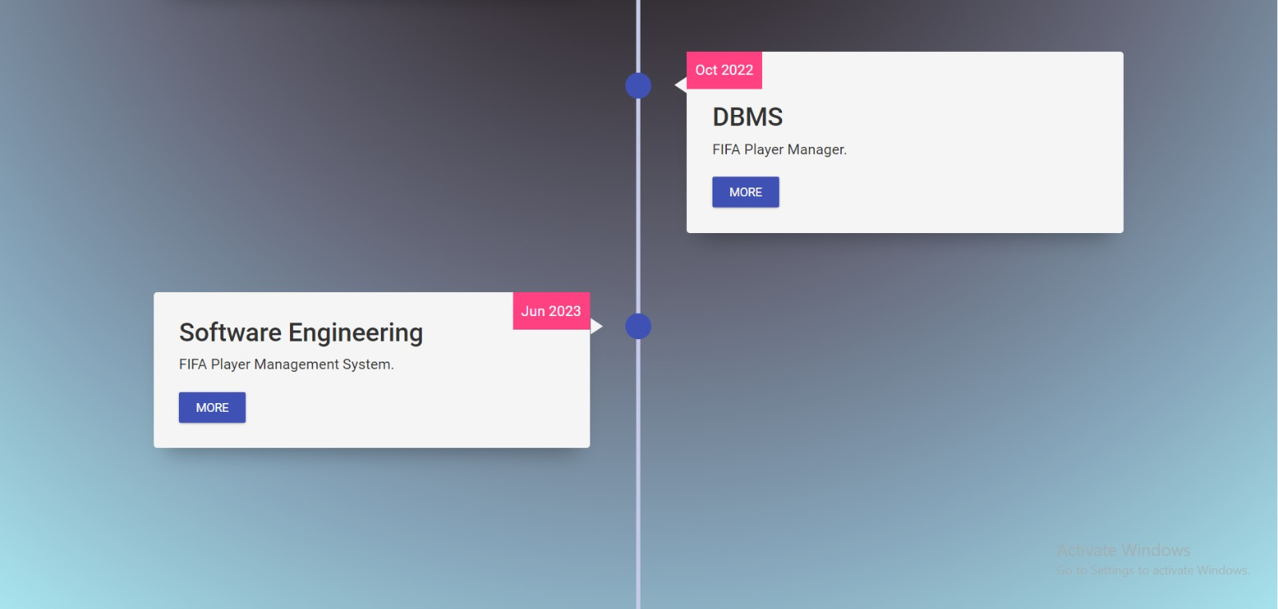

# **CONCLUSION**

This project is developed according to the needs of a user/scouting agent to monitor players and inspect their technicalities from every aspect on a soccer field. This is a computerized version of player management system which will benefit the players as well as the staff of a club.

In this entire process one can search player details, add new skilled players, Update ratings and view all the player statistics. The software takes care data and carefully stores all the player information.

# **FUTURE SCOPE**

There is a future scope of this project is to help managers and club staffs to get out the best youth talent across the world. Features like predicting players rating based on their current performances and training sessions helps team staffs to judge players according to the club’s needs.

**REFERENCES**

* Database System Model, Languages, Design and Application Programming, Ramez Elmasri and ShamKant B. Navathe, 7th edition, 2017, Pearson.
* Stackoverflow.com
* Quora.com
* w3schools.com